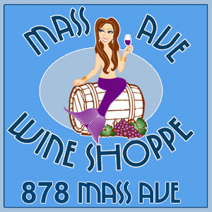 &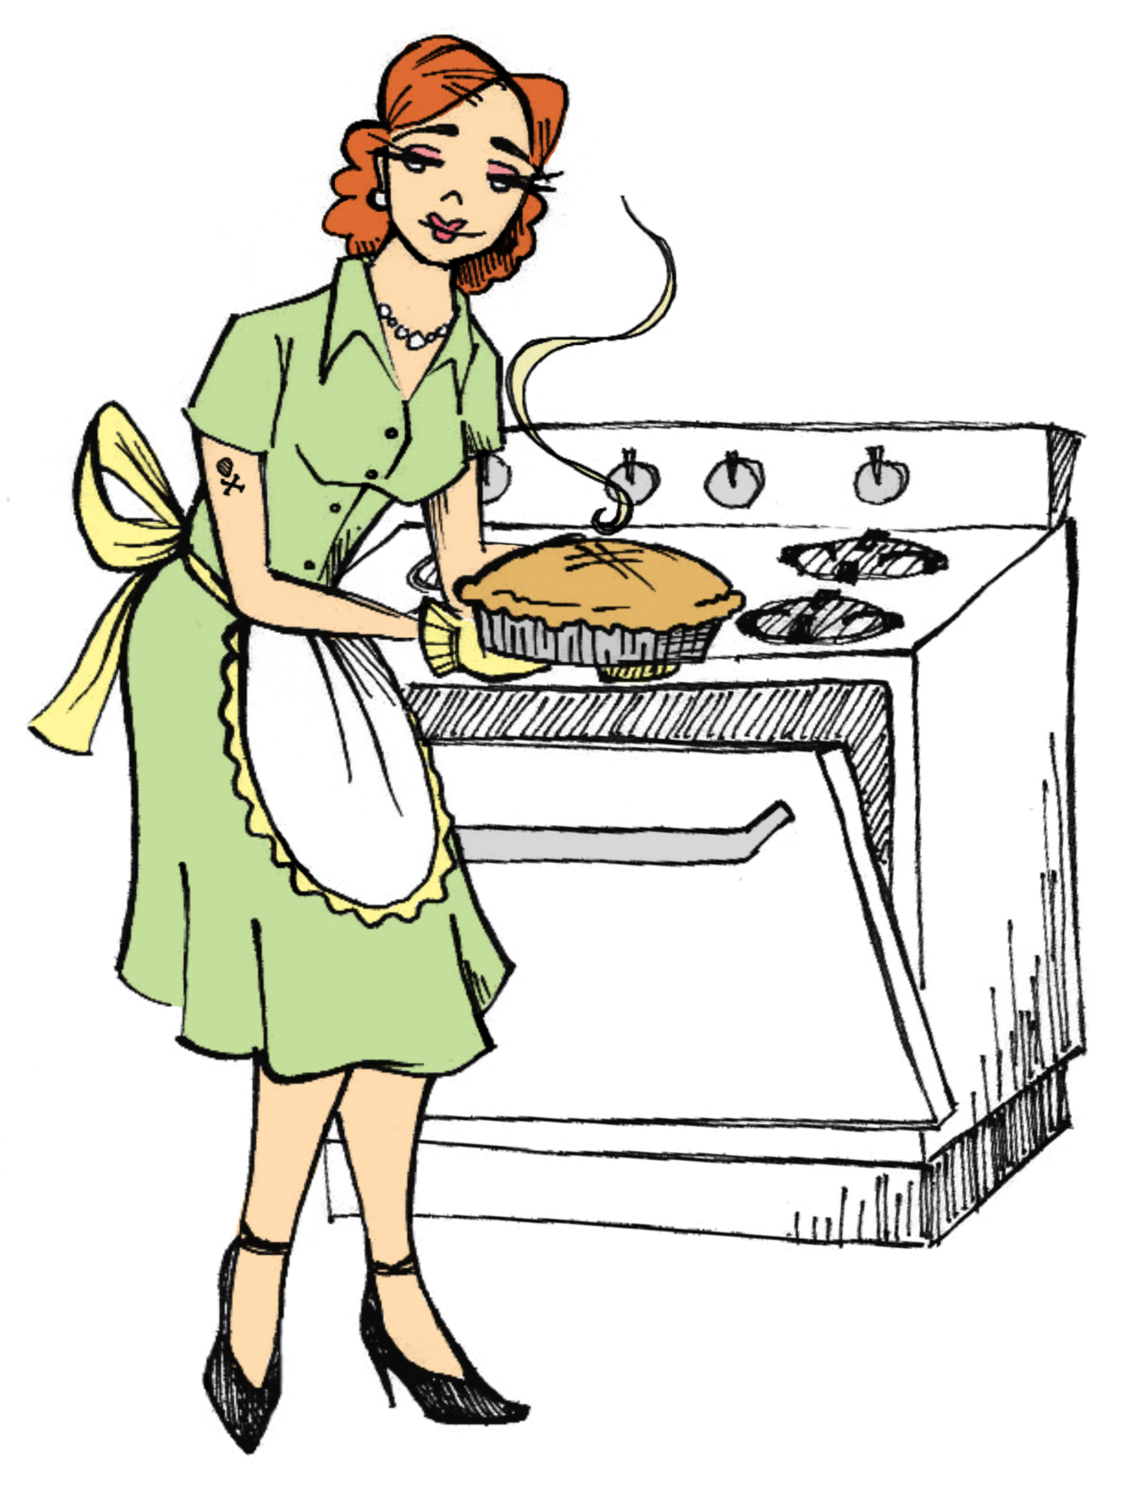
Present
KNIT One, SWIRL Two at Mass Ave Wine Shop
4:30-6:00 p.m. Saturdays February 13, 20, 27, and March 6.
$15 for a glass of wine and a knitting lesson!

Learn the basics of knitting such as how to cast on, cast off, knit, purl, change colors, knit cables, knit in the round and much more! Patterns will be provided each week for both beginner and more advanced knitters and I will be there for the entire hour and a half to teach newbies, or assist the seasoned knitter in a new challenge. In the first six weeks we will learn how to make a scarf, a hat, and a pair of wrist warmers to get us through the rest of the winter! You are welcome to join us any time!

PLEASE NOTE THERE IS NO CLASS ON FEBRUARY 6th!

Extra needles will be available during class time (thought they will need returned at the end of class) and lots of FREE yarn will be available to choose from, but you may also visit a store such as Joann’s, Michael’s, or Hobby Lobby, or Indy’s own local Mass Ave Knit Shop (on Virginia) to purchase yarn and needles.
Week THREE February 13th

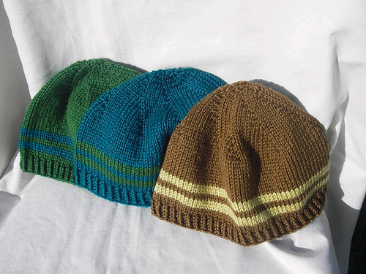
Beginners- Continue to practice knitting and purling. This week we will learn how to increase and decrease stitches to make a very basic hat. In this third session you will learn how knit a simple but functional beanie style hat. Materials needed to make this scarf include size 7 US knitting needles and 1 ball of yarn (worsted weight) such as Vanna’s Choice yarn or any Lion Brand worsted weight yarn, or worsted weight yarn of your choice. (p.s. the yarn label will tell you what “weight” it is!) We will also learn how to read patterns!

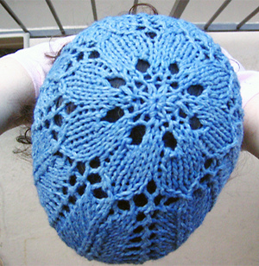
Advanced knitters (you know how to knit and purl and knit in the round) will be working on lace knitting skills this week! Materials needed include DOUBLE POINT size 9 US knitting needles, and approximately 350 yards of worsted weight yarn such as Vanna’s Choice yarn or any Lion Brand worsted weight yarn, and 4 stitch markers.

